WEEK 4 – MORE C PROGRAMMING
BY - NISARGA VISHWAMANJUSWAMY

- Chapter 11, do exercises 1, 3 and 4 on page 255.

Exercise 1:
If i is a variable and p points to i, which of the following expressions are aliases for i? (a) *p (b) &р (c) *&р (d) &*p (e)* i (f) &i (g)* &i (h) &*i

SOLUTION:

(a) *p: This dereferences `p`, yielding the value of `i`. (This is an alias for `i`.)

(b) &p: This gives the address of the pointer `p`, not the address of `i`. (This is not an alias for `i`.)

(c) *&p: This takes the address of `p` and then dereferences it, which results in `p` itself (not `i`). (This is not an alias for `i`.)

(d) &*p: This dereferences `p` to get `i` and then takes the address of `i`. (This is the address of `i`, so it is not an alias itself, but it effectively resolves to `&i`.)

(e) *i: This expression is invalid since `i` is not a pointer. (This is not applicable.)

(f) &i: This expression gives the address of `i`. (This is not an alias for `i`.)

(g) *&i: This takes the address of `i` and then dereferences it, resulting in `i`. (This is an alias for `i`.)

(h) &*i: This is invalid as `i` is not a pointer. (This is not applicable.)

EXAMPLE PROGRAM:

#include <stdio.h>

int main() {
int i = 42;
int *p = &i;

printf("*p: %d\n", *p);
printf("&p: %p\n", (void*)&p);
printf("*&p: %p\n", (void*)&p);
printf("&*p: %p\n", (void*)&i);
// printf("*i: %d\n", *i); // Invalid, uncommenting will cause error
printf("&i: %p\n", (void*)&i);
printf("*&i: %d\n", *&i);
// printf("&*i: %d\n", &*i); // Invalid, uncommenting will cause error

return 0;
}
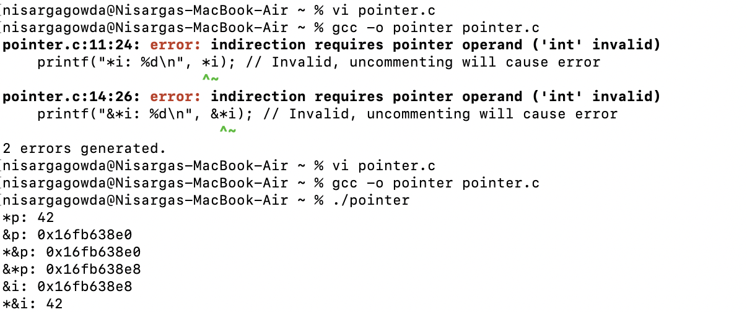

Not able to execute *i and &*i, since they are giving error as indirection requires pointer operand ('int' invalid)- anyways they aren’t the aliases of i.

So from above example program, we can clearly say that *p and *&I is the aliases for i.

Exercise 3:
The following function supposedly computes the sum and average of the numbers in the array a, which has length n. avg and sum point to variables that the function should modify. Unfortunately, the function contains several errors; find and correct them.
void avg_sum(double a[], int n, double *avg, double *sum)
{
int i;
sum = 0. 0;
for（i=0; i < n; i++)
sum += a [i];
avg = sum / n;
}

SOLUTION:

Issues Identified:
- Incorrect Initialization
- Syntax Errors
- Average Calculation

• Pointer Dereferencing:
- The original code tried to assign values directly to the pointers avg and sum. Instead, you need to dereference these pointers using * to modify the values they point to.
• Initialization:
- The line sum = 0.0; was incorrect. It should be *sum = 0.0; to set the value pointed to by sum to zero.
• Correct Average Calculation:
The line avg = sum / n; should be *avg = *sum / n; to correctly compute the average.

EXAMPLE PROGRAM:

#include <stdio.h>
#include <stdlib.h>

void avg_sum(double a[], int n, double *avg, double *sum) {
int i;
*sum = 0.0;

for (i = 0; i < n; i++) {
*sum += a[i];
}

if (n > 0) {
*avg = *sum / n;
} else {
*avg = 0.0;
}
}

int main() {
int n;
double average, total;

printf("Enter the number of elements: ");
scanf("%d", &n);

double *numbers = (double *)malloc(n * sizeof(double));

if (numbers == NULL) {
printf("Memory allocation failed!\n");
return 1;
}

printf("Enter %d numbers:\n", n);
for (int i = 0; i < n; i++) {
scanf("%lf", &numbers[i]);
}

avg_sum(numbers, n, &average, &total);

printf("Sum: %.2f\n", total);
printf("Average: %.2f\n", average);

free(numbers);

return 0;
}

OUTPUT:

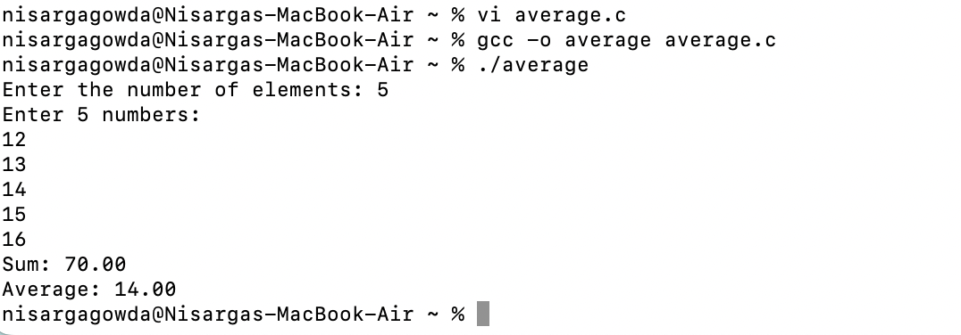

Exercise 4:
﻿﻿Write the following function:
void swap (int *p, int *q) ;
When passed the addresses of two variables, swap should exchange the values of the variables:
swap (&i, &j); /* exchanges values of i and j */

SOLUTION:

- When we call swap(&i, &j), the addresses of i and j are passed to the swap function.
- Inside the swap function, the values at those addresses are exchanged.

EXAMPLE PROGRAM:

#include <stdio.h>

void swap(int *p, int *q) {
int temp = *p;
*p = *q;
*q = temp;
}

int main() {
int i, j;

printf("Enter the value for i: ");
scanf("%d", &i);
printf("Enter the value for j: ");
scanf("%d", &j);

printf("Before swap: i = %d, j = %d\n", i, j);
swap(&i, &j);
printf("After swap: i = %d, j = %d\n", i, j);

return 0;
}

OUTPUT:
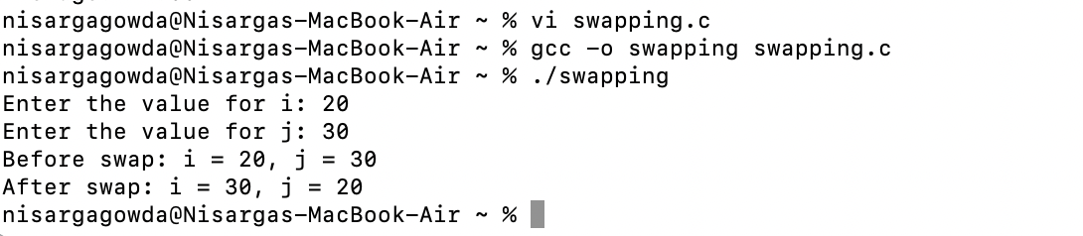

- Chapter 12, do exercises 1, 5 and 8 on page 273 - page 274.

Exercise 1:
Suppose that the following declarations are in effect:
int a [ ] = {5, 15, 34, 54, 14, 2, 52, 72};
int *p = &a [1], *q = &a [5] ;
- ﻿﻿﻿﻿What is the value of * (p+3) ?
- ﻿﻿﻿﻿What is the value of * (q-3)?
- ﻿﻿﻿﻿What is the value of q - p?
- ﻿﻿﻿﻿Is the condition p < q true or false?
e. Is the condition *p < * q true or false?
SOLUTION:
a. What is the value of *(p + 3)?
- p + 3 points to the element that is 3 positions after p, which is &a[1 + 3] = &a[4].
- The value at a[4] is 14.
- Value: 14

b. What is the value of *(q - 3)?
- q - 3 points to the element that is 3 positions before q, which is &a[5 - 3] = &a[2].
- The value at a[2] is 34.
- Value: 34

c. What is the value of q - p?
- q points to &a[5] and p points to &a[1].
- The difference q - p is the number of elements between these two pointers: 5 - 1 = 4.
- Value: 4

d. Is the condition p < q true or false?
- Since p points to &a[1] and q points to &a[5], we have 1 < 5.
- Therefore, the condition p < q is true.

e. Is the condition *p < *q true or false?
- *p is the value at a[1], which is 15, and *q is the value at a[5], which is 2.
- The condition 15 < 2 is false.

EXAMPLE PROGRAM:
#include <stdio.h>

int main() {
int a[] = {5, 15, 34, 54, 14, 2, 52, 72};
int *p = &a[1];
int *q = &a[5];

printf("Value of *(p + 3): %d\n", *(p + 3));
printf("Value of *(q - 3): %d\n", *(q - 3));
printf("Value of q - p: %ld\n", (q - p));
printf("Is p < q? %s\n", (p < q) ? "true" : "false");
printf("Is *p < *q? %s\n", (*p < *q) ? "true" : "false");

return 0;
}

OUTPUT:
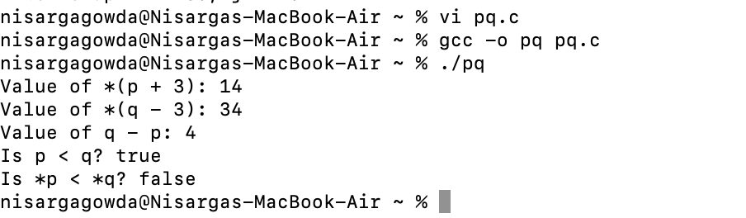

Exercise 5:

Suppose that a is a one-dimensional array and p is a pointer variable. Assuming that the assignment p = a has just been performed, which of the following expressions are illegal because of mismatched types? Of the remaining expressions, which are true (have a nonzero value)?
  - p == a [0]
  - p == &a [0]
  - *p == a [0]
  - p[0] == a [0]

a. p == a[0]
- Type: p is a pointer (int*), and a[0] is an integer.
- Legality: Illegal due to mismatched types.
- Truth Value: N/A (illegal).
b. p == &a[0]
- Type: p is a pointer to int, and &a[0] is also a pointer to int.
- Legality: Legal, as both are of the same type.
- Truth Value: This will be true (non-zero) because p points to the first element of a.
c. *p == a[0]
- Type: *p dereferences the pointer p, giving the value of a[0] (an integer).
- Legality: Legal, as both are integers.
- Truth Value: This will be true (non-zero) because *p equals a[0].
d. p[0] == a[0]
- Type: p[0] is the same as *p, which gives the value of a[0].
- Legality: Legal, as both are integers.
- Truth Value: This will also be true (non-zero) because p[0] equals a[0].

EXAMPLE PROGRAM:

#include <stdio.h>

int main() {
int a[] = {5, 15, 34, 54, 14};
int *p = a;

printf("p == a[0]: %s\n", (p == a[0]) ? "true" : "false");
printf("p == &a[0]: %s\n", (p == &a[0]) ? "true" : "false");
printf("*p == a[0]: %s\n", (*p == a[0]) ? "true" : "false");
printf("p[0] == a[0]: %s\n", (p[0] == a[0]) ? "true" : "false");

return 0;
}

OUTPUT:
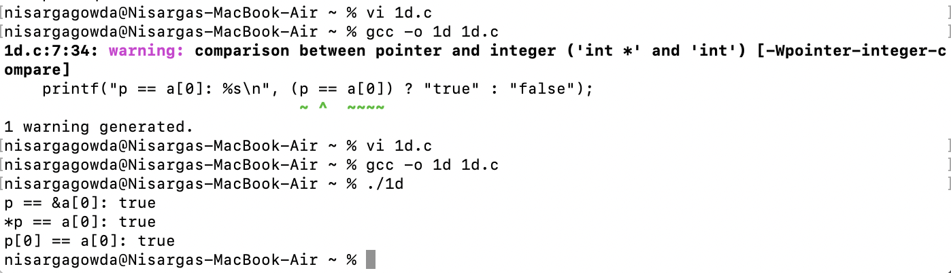

Exercise 8:

﻿﻿﻿Rewrite the following function to use pointer arithmetic instead of array subscripting. (In other words, eliminate the variable i and all uses of the [] operator.) Make as few changes as possible.
void store_zeros (int a[], int n)
{
int i;
for (i = 0; i < n; i++)
a [i] = 0;
}

SOLUTION:

Changes Made
- Removed the variable i.
- Used a pointer end to point to the end of the array.
- Replaced the array subscript a[i] with pointer dereferencing *a.

void store_zeros(int *a, int n) {
int *end = a + n;
while (a < end) {
*a = 0;
a++;
}
}

EXAMPLE PROGRAM:
#include <stdio.h>

void store_zeros(int *a, int n) {
int *end = a + n;
while (a < end) {
*a = 0;
a++;
}
}

int main() {
int arr[5] = {1, 2, 3, 4, 5};
store_zeros(arr, 5);

for (int j = 0; j < 5; j++) {
printf("%d ", arr[j]);
}
printf("\n");

return 0;
}

OUTPUT:
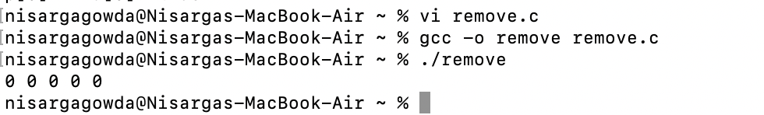

- Chapter 11, do exercises 1 and 8 on page 255 - page 256.

Exercise 1:
If i is a variable and p points to i, which of the following expressions are aliases for i? (a) *p (b) &р (c) *&р (d) &*p (e)* i (f) &i (g)* &i (h) &*i

REPEATED QUESTION. ANSWERED IT IN ABOVE EXERCISE

Exercise 8:
Write the following function:
int *find_largest (int a[], int n) ;
When passed an array a of length n, the function will return a pointer to the array's largest
element.

SOLUTION:

#include <stdio.h>

int *find_largest(int a[], int n) {
if (n <= 0) return NULL;
int *largest = &a[0];
for (int i = 1; i < n; i++) {
if (a[i] > *largest) {
largest = &a[i];
}
}
return largest;
}

int main() {
int n;
printf("Enter the number of elements in the array: ");
scanf("%d", &n);

if (n <= 0) {
printf("Array size must be positive.\n");
return 1;
}

int arr[n];
printf("Enter %d elements:\n", n);
for (int i = 0; i < n; i++) {
scanf("%d", &arr[i]);
}

int *largest = find_largest(arr, n);
printf("Largest element: %d\n", *largest);

return 0;
}

OUTPUT:

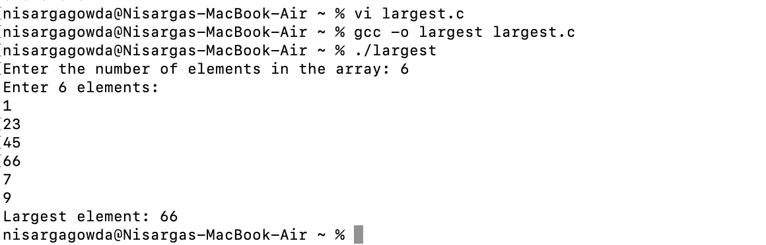

- Chapter 12, do exercises 1 and 17 on page 273, page 274 and page 275.

Exercise 1:

Suppose that the following declarations are in effect:
int a [ ] = {5, 15, 34, 54, 14, 2, 52, 72};
int *p = &a [1], *q = &a [5] ;
- ﻿﻿﻿﻿What is the value of * (p+3) ?
- ﻿﻿﻿﻿What is the value of * (q-3)?
- ﻿﻿﻿﻿What is the value of q - p?
- ﻿﻿﻿﻿Is the condition p < q true or false?
Is the condition *p < * q true or false?

REPEATED QUESTION. ANSWERED IT IN ABOVE EXERCISE

Exercise 17:

﻿Rewrite the following function to use pointer arithmetic instead of array subscripting. (In other words, eliminate the variables i and j and all uses of the [] operator.) Use a single loop instead of nested loops.
int sum_two _dimensional_array (const int a[] [LEN], int n)
{
int i, j, sum = 0;
for (i = 0; i < n; i++)
for (j = 0; j < LEN; j++)
sum += a [i] [j];
return sum;
}

SOLUTION:

#include <stdio.h>

#define LEN 3

int sum_two_dimensional_array(const int (*a)[LEN], int n) {
int sum = 0;
const int *end = *a + (n * LEN);
const int *ptr = *a;

while (ptr < end) {
sum += *ptr;
ptr++;
}

return sum;
}

int main() {
const int array[2][LEN] = {
{1, 2, 3},
{4, 5, 6}
};

int total = sum_two_dimensional_array(array, 2);
printf("Sum: %d\n", total);

return 0;
}

OUTPUT:
